Significant Figures
# Source: AI Source: Provided by: [Data Path: Persons Table -> ID Column: 1, Name_En Column: Motasem Essam] -> From: [ChatGPT] on [7/17/2026]
Significant Figures (or Significant Digits) are the meaningful digits in a measured value that indicate its precision. They include all certain digits plus the first uncertain (estimated) digit recorded during a measurement.
Significant figures communicate how accurately a quantity has been measured, preventing calculations from implying greater precision than the measurements actually support.

Definition
# Source: AI Source: Provided by: [Data Path: Persons Table -> ID Column: 1, Name_En Column: Motasem Essam] -> From: [ChatGPT] on [7/17/2026]
Significant Figures are the digits in a measured number that contribute to its precision, consisting of all known certain digits and one estimated digit.

Purpose
# Source: AI Source: Provided by: [Data Path: Persons Table -> ID Column: 1, Name_En Column: Motasem Essam] -> From: [ChatGPT] on [7/17/2026]
Significant figures are used to:
- Express measurement precision.
- Indicate the reliability of measured values.
- Prevent false precision in calculations.
- Standardize scientific reporting.
- Improve communication of experimental results.

Characteristics
# Source: AI Source: Provided by: [Data Path: Persons Table -> ID Column: 1, Name_En Column: Motasem Essam] -> From: [ChatGPT] on [7/17/2026]
Significant figures:
- Apply only to measured quantities.
- Reflect the precision of the measuring instrument.
- Are used in science, engineering, mathematics, and metrology.
- Affect the rounding of calculation results.

Rules for Determining Significant Figures

Rule 1: All Non-Zero Digits Are Significant
# Source: AI Source: Provided by: [Data Path: Persons Table -> ID Column: 1, Name_En Column: Motasem Essam] -> From: [ChatGPT] on [7/17/2026]
Every non-zero digit is significant.
Examples:
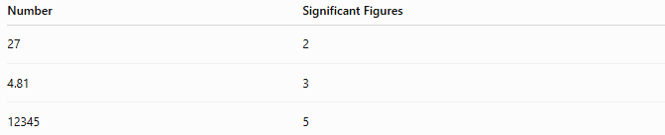
Number | Significant Figures
27 | 2
4.81 | 3
12345 | 5

Rule 2: Zeros Between Non-Zero Digits Are Significant
# Source: AI Source: Provided by: [Data Path: Persons Table -> ID Column: 1, Name_En Column: Motasem Essam] -> From: [ChatGPT] on [7/17/2026]
Zeros located between non-zero digits are always significant.
Examples:
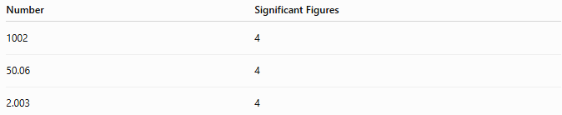
Number | Significant Figures
1002 | 4
50.06 | 4
2.003 | 4

Rule 3: Leading Zeros Are Not Significant
# Source: AI Source: Provided by: [Data Path: Persons Table -> ID Column: 1, Name_En Column: Motasem Essam] -> From: [ChatGPT] on [7/17/2026]
Zeros before the first non-zero digit only locate the decimal point.
Examples:
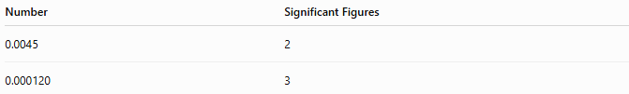
Number | Significant Figures
0.0045 | 2
0.000120 | 3

Rule 4: Trailing Zeros to the Right of a Decimal Point Are Significant
# Source: AI Source: Provided by: [Data Path: Persons Table -> ID Column: 1, Name_En Column: Motasem Essam] -> From: [ChatGPT] on [7/17/2026]
These zeros indicate measurement precision.
Examples:

Number | Significant Figures
2.300 | 4
45.00 | 4
8.1000 | 5

Rule 5: Trailing Zeros in Whole Numbers Without a Decimal Point May Be Ambiguous
# Source: AI Source: Provided by: [Data Path: Persons Table -> ID Column: 1, Name_En Column: Motasem Essam] -> From: [ChatGPT] on [7/17/2026]
Examples:
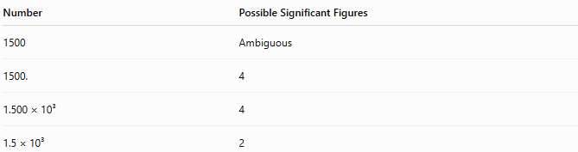
Number | Possible Significant Figures
1500 | Ambiguous
1500. | 4
1.500 × 10³ | 4
1.5 × 10³ | 2
Scientific notation removes this ambiguity.

Counting Significant Figures
# Source: AI Source: Provided by: [Data Path: Persons Table -> ID Column: 1, Name_En Column: Motasem Essam] -> From: [ChatGPT] on [7/17/2026]
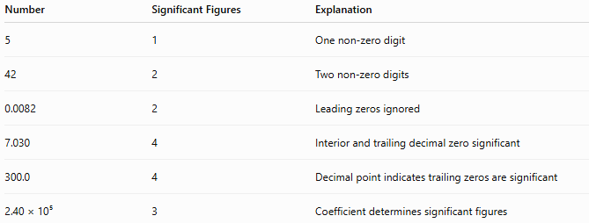
Number | Significant Figures | Explanation
5 | 1 | One non-zero digit
42 | 2 | Two non-zero digits
0.0082 | 2 | Leading zeros ignored
7.030 | 4 | Interior and trailing decimal zero significant
300.0 | 4 | Decimal point indicates trailing zeros are significant
2.40 × 10⁵ | 3 | Coefficient determines significant figures

Scientific Notation
# Source: AI Source: Provided by: [Data Path: Persons Table -> ID Column: 1, Name_En Column: Motasem Essam] -> From: [ChatGPT] on [7/17/2026]
Scientific notation clearly indicates significant figures.
Examples:
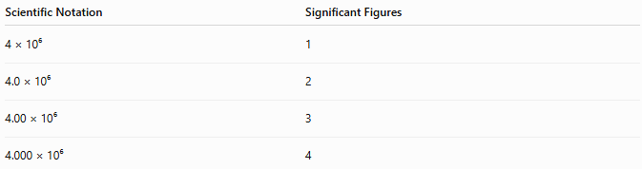
Scientific Notation | Significant Figures
4 × 10⁶ | 1
4.0 × 10⁶ | 2
4.00 × 10⁶ | 3
4.000 × 10⁶ | 4

Significant Figures in Calculations

Addition and Subtraction
# Source: AI Source: Provided by: [Data Path: Persons Table -> ID Column: 1, Name_En Column: Motasem Essam] -> From: [ChatGPT] on [7/17/2026]
The result should have the same number of decimal places as the least precise measurement.
Example:
12.45 + 3.2 = 15.65
Rounded result:
15.7
Reason:
The value 3.2 has only one decimal place.

Multiplication and Division
# Source: AI Source: Provided by: [Data Path: Persons Table -> ID Column: 1, Name_En Column: Motasem Essam] -> From: [ChatGPT] on [7/17/2026]
The result should have the same number of significant figures as the value with the fewest significant figures.
Example:
4.52 × 2.1 = 9.492
Rounded result:
9.5
Reason:
2.1 has 2 significant figures.

Exact Numbers
# Source: AI Source: Provided by: [Data Path: Persons Table -> ID Column: 1, Name_En Column: Motasem Essam] -> From: [ChatGPT] on [7/17/2026]
Some numbers are exact and have unlimited significant figures.
Examples:
- 12 eggs
- 5 students
- 60 seconds in one minute
- 100 centimeters in one meter (defined conversion)
Exact numbers do not limit the precision of calculations.

Importance
# Source: AI Source: Provided by: [Data Path: Persons Table -> ID Column: 1, Name_En Column: Motasem Essam] -> From: [ChatGPT] on [7/17/2026]
Significant figures:
- Prevent reporting unrealistic precision.
- Reflect measurement quality.
- Improve scientific communication.
- Standardize engineering calculations.
- Support reliable experimental analysis.

Common Mistakes
# Source: AI Source: Provided by: [Data Path: Persons Table -> ID Column: 1, Name_En Column: Motasem Essam] -> From: [ChatGPT] on [7/17/2026]
- Counting leading zeros as significant.
- Ignoring trailing zeros after a decimal point.
- Treating exact numbers like measured values.
- Forgetting that addition/subtraction use decimal places, while multiplication/division use significant figures.
- Reporting more digits than justified by the measurements.

Applications
# Source: AI Source: Provided by: [Data Path: Persons Table -> ID Column: 1, Name_En Column: Motasem Essam] -> From: [ChatGPT] on [7/17/2026]
Significant figures are widely used in:
- Physics
- Chemistry
- Engineering
- Metrology
- Laboratory measurements
- Environmental science
- Manufacturing
- Surveying

Summary Table
# Source: AI Source: Provided by: [Data Path: Persons Table -> ID Column: 1, Name_En Column: Motasem Essam] -> From: [ChatGPT] on [7/17/2026]
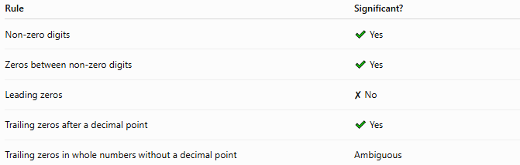
Rule | Significant?
Non-zero digits | ✔ Yes
Zeros between non-zero digits | ✔ Yes
Leading zeros | ✘ No
Trailing zeros after a decimal point | ✔ Yes
Trailing zeros in whole numbers without a decimal point | Ambiguous

Key Points
# Source: AI Source: Provided by: [Data Path: Persons Table -> ID Column: 1, Name_En Column: Motasem Essam] -> From: [ChatGPT] on [7/17/2026]
- Significant figures indicate the precision of a measured value.
- They include all certain digits and one estimated digit.
- Leading zeros are never significant.
- Zeros between non-zero digits are always significant.
- Trailing decimal zeros are significant.
- Scientific notation clearly shows the intended number of significant figures.
- The rules for addition/subtraction differ from those for multiplication/division.

Conclusion
# Source: AI Source: Provided by: [Data Path: Persons Table -> ID Column: 1, Name_En Column: Motasem Essam] -> From: [ChatGPT] on [7/17/2026]
Significant Figures are the meaningful digits in a measured quantity that represent its precision and reliability. They include every certain digit recorded during measurement along with the first uncertain (estimated) digit. By following consistent rules for identifying and using significant figures, scientists and engineers ensure that reported values accurately reflect the quality of the measurements and avoid implying a level of precision that the measuring instrument cannot support. As a result, significant figures are a fundamental part of scientific measurement, engineering calculations, laboratory work, and metrology.

